Name: Amol Shivaji Tambekar Roll No:54 Batch:3
Step 1: Create Table
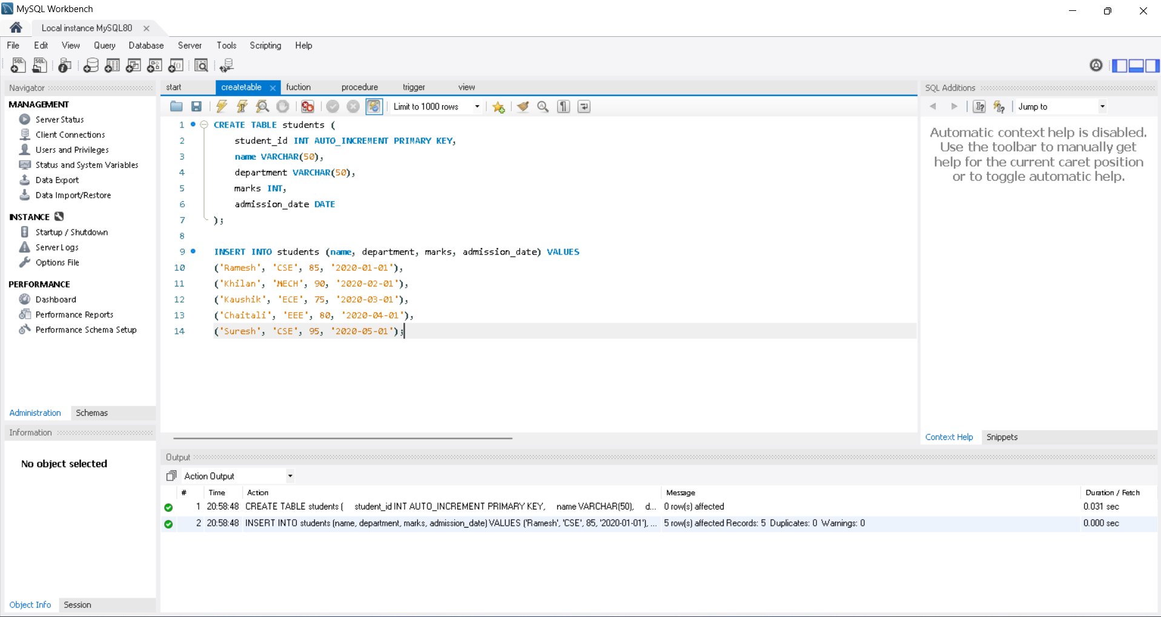

Step 2: Implement Functions
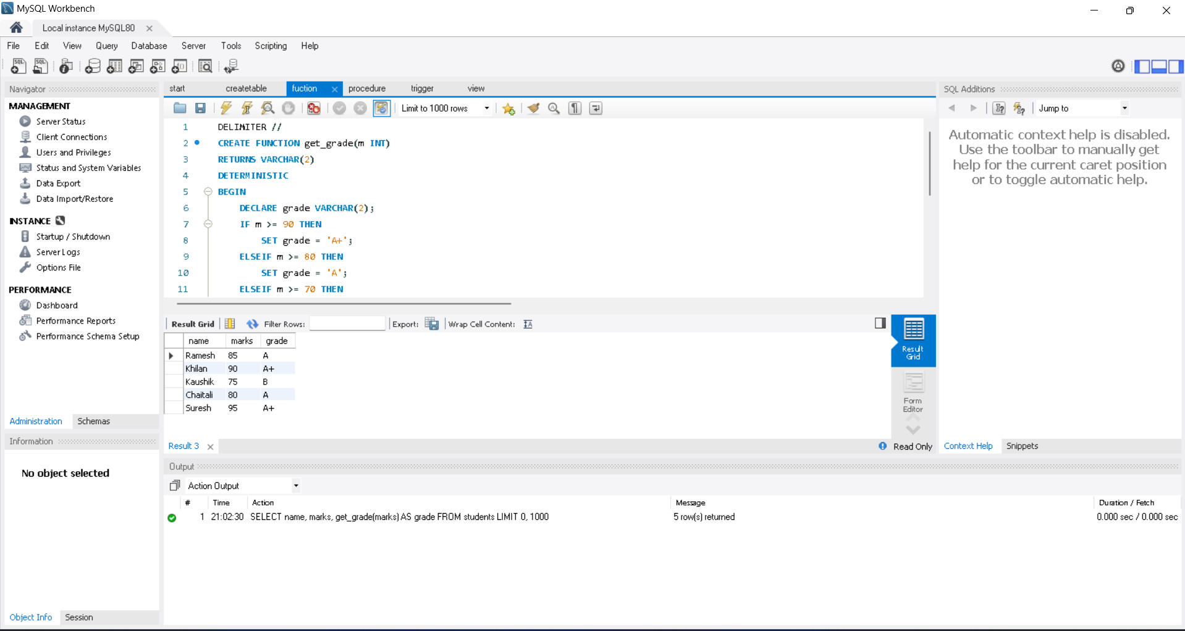
Step 3: Implement Procedures
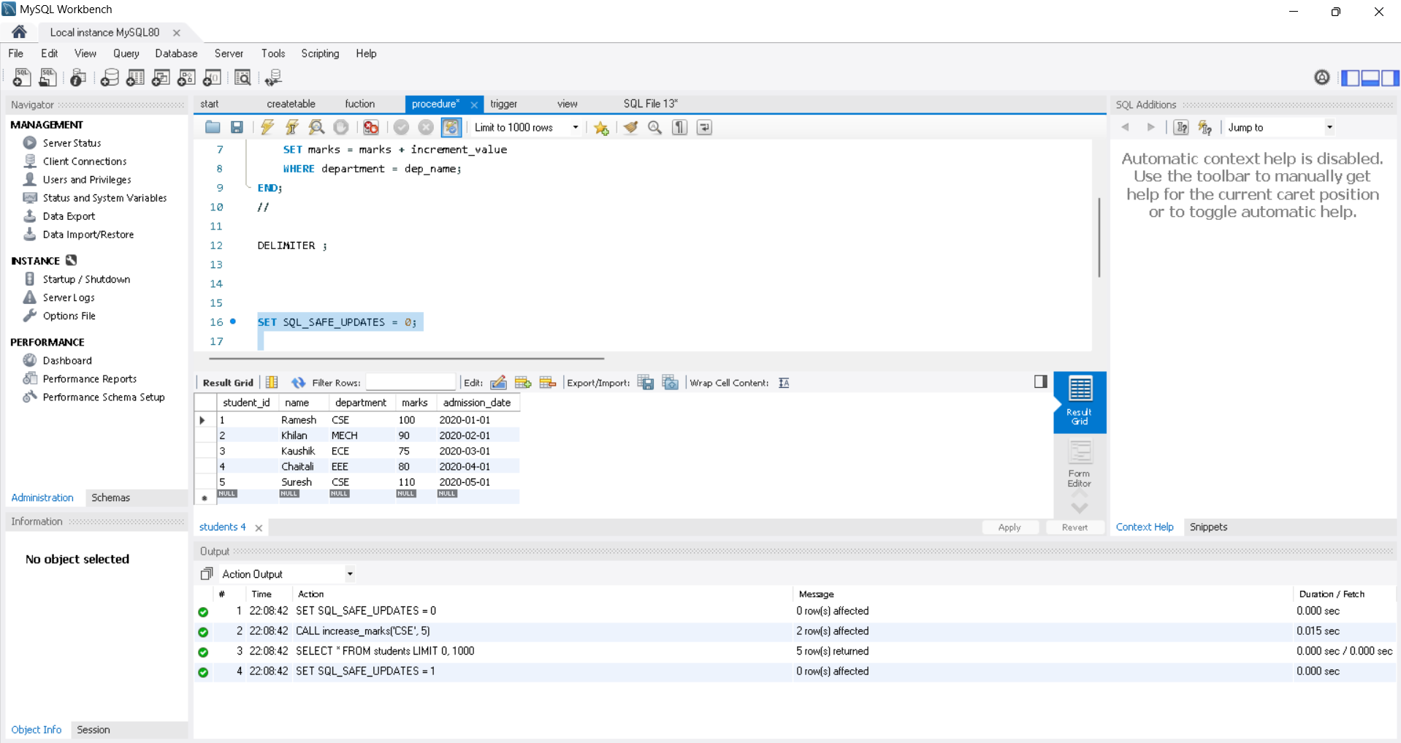

Step 4: Implement SQL Cursor
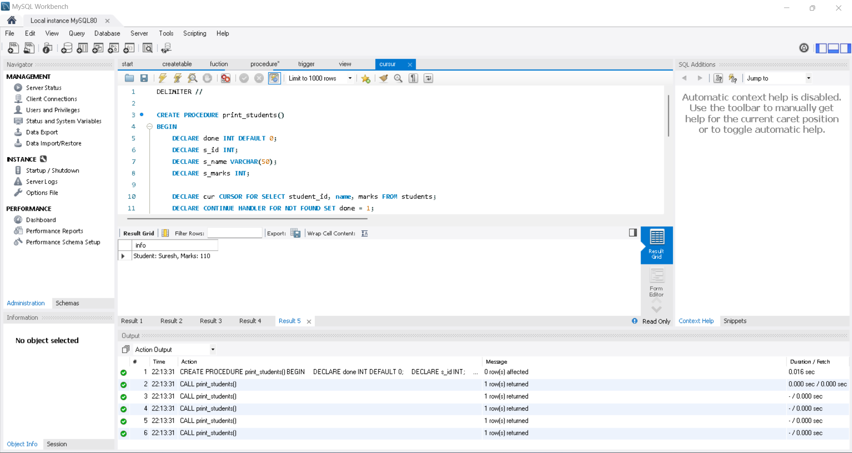
Step 5: Implement SQL Trigger
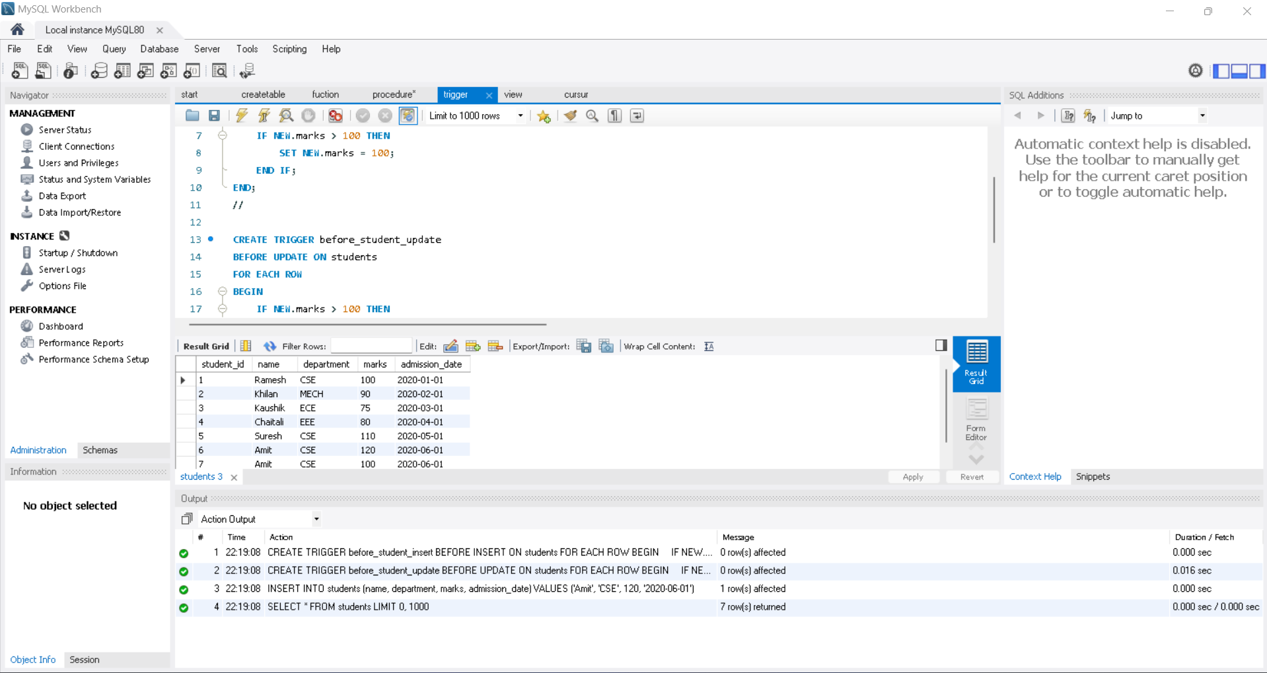

Step 6: Implement SQL View
